LAKSHMI NARAIN COLLEGE OF TECHNOLOGY & SCIENCE,
BHOPAL (M.P)

DEPARTMENT OF COMPUTER SCIENCE & ENGINEERING-
Cyber Security


CERTIFICATE

This is to certify that the work embodied in this Minor Project - II work entitled “Project Title ” has been satisfactorily completed by the Student 1 (Enrolment no), Student 2 (Enrolment no)) , Student 3 (Enrolment no)) , Student 4 (Enrolment no)). It is a bonafide piece of work, carried out under the guidance, Prof. x….y…..z, from Department of Computer Science & Engineering- Cyber Security, Lakshmi Narain College of Technology & Science, Bhopal for the partial fulfilment of the Bachelor of Technology during the academic year 2025-26.

Under the Guidance of
Prof / Dr.X….Y…..Z

Approved By

Dr. BhupeshGour
Prof. & Head
Department of Computer Science & Engineering-
Cyber Security

Forwarded By
Dr. V.N. Bartaria
Principal
LAKSHMI NARAIN COLLEGE OF TECHNOLOGY & SCIENCE BHOPAL (M.P.)

DEPARTMENT OF COMPUTER SCIENCE & ENGINEERING-
Cyber Security



CERTIFICATE OF APPROVAL

This foregoing project work is hereby approved as a creditable study of Engineering carried out and presented in a manner satisfactory to warranty its acceptance as a prerequisite to the degree for which it has been submitted. It is understood that by this approval the undersigned do not necessarily endorse or approve any statement made, opinion expressed or conclusion drawn there in, but approve the project only for the purpose for which it has been submitted.

Internal Examiner External Examiner

Date:

LAKSHMI NARAIN COLLEGE OF TECHNOLOGY & SCIENCE BHOPAL (M.P.)

DEPARTMENT OF COMPUTER SCIENCE & ENGINEERING-
Cyber Security



DECLARATION

We, Student 1 (Enrolment no), Student 2 (Enrolment no), Student 3 (Enrolment no), Student 4 (Enrolment no). student of “Bachelor of Technology in Computer Science & Engineering- Cyber Security”, Session: 2025 - 26, Lakshmi Narain College of Technology & Science Bhopal (M.P.), hereby declare that the work presented in this project entitled“XXXX XXXXXXXX” is the outcome of our own work, is bonafide and correct to the best of our knowledge and this work has been carried out taking care of Engineering Ethics. The work presented does not infringe any patented work and has not been submitted to any other University or anywhere else for the award of any degree or any professional diploma.

……………………….. …………………………
Student 1 Student 2
(Enrolment no) (Enrolment no)

……………………….. …………………………
Student 3 Student 4
(Enrolment no) (Enrolment no)

Place: Bhopal

Date:

LAKSHMI NARAIN COLLEGE OF TECHNOLOGY&SCIENCE, BHOPAL (M.P.)

DEPARTMENT OF COMPUTER SCIENCE & ENGINEERING-
Cyber Security



ACKNOWLEDGEMENT

We express our deep sense of gratitude to Prof. x….y….z , Department of Computer Science & Engineering- Cyber Security, Lakshmi Narain College of Technology and Science, Bhopal, whose valuable guidance and timely help encouraged me to complete this project.

A special thanks goes to Dr.Bhupesh Gour ,Prof.& Head of Department, who helped me by providing timely suggestions in completing this project work. He/She exchanged his/her interesting ideas & thoughts which made this project work successful.

I am equally to Dr. V. N. Bartaria, Principal, LNCT&S, for providing all the necessary resources to carry out the research work.

We would alsothank our institution and all the faculty members without whom this project work would have been a distant reality.

Student 1 Student 2
(Enrolment no) (Enrolment no)

Student 3 Student 4
(Enrolment no) (Enrolment no)

ABSTRACT

TABLE OF CONTENTS

- DECLARATION ...........................................................................................III
- CERTIFICATE OF APPROVAL..................................................................IV
- ACKNOWLEDGEMENT..............................................................................VI
- ABSTRACT..................................................................................................VII
- TABLE OF CONTENT...............................................................................VIII
- LIST OF TABLES.........................................................................................IX
- LIST OF FIGURES.........................................................................................X
- LIST OF SYMBOLS AND ABBREVIATIONS...........................................XI
- GLOSSARY..................................................................................................XII

Chapter 1: Introduction……………………………………...……………………1
1.1 Introduction to project ..................................................................1
1.2 Project Category ...........................................................................1
1.3 Motivation ....................................................................................2
1.4 Problem Definition........................................................................2
1.5 Goals and Objectives.....................................................................2
1.6 Scope and Applications.................................................................3
1.7 Identification/Reorganization of Need.............................................3
1.8 Existing System................................................................................4
1.9 Proposed System..............................................................................5
1.10 Unique Features of the System.......................................................6

Chapter 2: Literature Review……………………………………………………8

Chapter 3: Requirement analysis……………………………………...………...12
3.1 Project requirements (Hardware and software)................................14
3.2 Feasibility study...............................................................................15

Chapter 4: System Design & Architecture……………………………………17
4.1 Block diagram or System Architecture or Circuit Diagram
4.2 ER-Diagram
4.3 Data Flow Diagram and other design methods and tools

Chapter 5: Methodology .............................................................................

Chapter 6: Implementation, Testing, and Maintenance ...............................
6.1Description of frontend code (client side)
6.2 Description of admin code (administration side)
6.3 Description of backend code (database)
6.4 Testing Techniques and Test Plans

Chapter 7: Result & Analysis ...........................................................................
7.1 User Interface Representation (of Respective Project)
7.2 Brief Description of Various Modules of the system
7.3 Snapshots of system with brief detail of each
7.4 Back Ends Representation (Database to be used )
7.5 Snapshots of Database Tables with brief description

Chapter 8: Conclusion & Future Work .............................................................
8.1 Conclusion
8.2 Limitations
8.3 Future Enhancement

Appendix
References / Bibliography

LIST OF TABLES

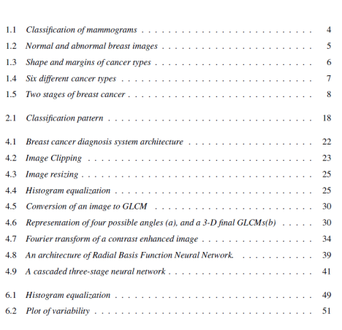

LIST OF FIGURES


LIST OF SYMBOLS AND ACRONYMS
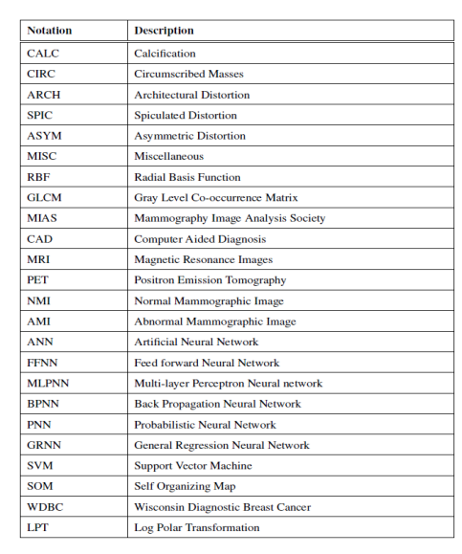

GLOSSARY
